**Experiment 3.2**

**Student Name:** Sahil Kaundal **UID:** 21BCS8197

**Branch:** CSE (Lateral Entry)  **Section/Group:** 616/A

**Semester:** 6th **Date of Performance:** 07/05/2023

**Subject Name:** Mobile Application Development Lab **Subject Code:** 20CSP-356

1. **Aim:**

Design the Android application using menus and action bar.

1. **Objective:**

* Understanding of the interactions between user interface and underlying application infrastructure.
* Design an android application which menus and action bar in android studio.

1. **System Requirements:**

* Microsoft Windows 7/8/10 (32-bit or 64-bit)
* 4 GB RAM minimum, 8 GB RAM recommended (plus 1 GB for the Android Emulator)
* 2 GB of available disk space minimum, 4 GB recommended (500 MB for IDE plus 1.5 GB for Android SDK and emulator system image)
* 1280 x 800 minimum screen resolution
* Java JDK5 or later version
* Java Runtime Environment (JRE) 6 Android Studio

1. **Steps/Program:**

**activity_main.xml**

<?xml version="1.0" encoding="utf-8"?>

<androidx.constraintlayout.widget.ConstraintLayout xmlns:android="http://schemas.android.com/apk/res/android"

xmlns:app="http://schemas.android.com/apk/res-auto"

xmlns:tools="http://schemas.android.com/tools"

android:layout_width="match_parent"

android:layout_height="match_parent"

tools:context=".MainActivity">

<EditText

android:id="@+id/editTextTextPersonName"

android:layout_width="wrap_content"

android:layout_height="wrap_content"

android:layout_marginBottom="30dp"

android:ems="10"

android:hint="Name"

android:inputType="textPersonName"

android:minHeight="48dp"

app:layout_constraintBottom_toTopOf="@+id/editTextTextPersonName2"

app:layout_constraintEnd_toEndOf="parent"

app:layout_constraintStart_toStartOf="parent" />

<EditText

android:id="@+id/editTextTextPersonName2"

android:layout_width="wrap_content"

android:layout_height="wrap_content"

android:layout_marginBottom="150dp"

android:ems="10"

android:hint="UID"

android:inputType="textPersonName"

android:minHeight="48dp"

app:layout_constraintBottom_toBottomOf="parent"

app:layout_constraintEnd_toEndOf="parent"

app:layout_constraintStart_toStartOf="parent" />

<Button

android:id="@+id/button"

android:layout_width="wrap_content"

android:layout_height="wrap_content"

android:layout_marginBottom="70dp"

android:text="Submit"

android:textSize="16sp"

app:layout_constraintBottom_toBottomOf="parent"

app:layout_constraintEnd_toEndOf="parent"

app:layout_constraintStart_toStartOf="parent" />

</androidx.constraintlayout.widget.ConstraintLayout>

**MainActivity.java**

package com.example.exp9;

import androidx.appcompat.app.AppCompatActivity;

import android.annotation.SuppressLint;

import android.os.Bundle;

import android.view.Menu;

import android.view.MenuInflater;

import android.view.MenuItem;

import android.widget.Toast;

public class MainActivity extends AppCompatActivity {

@Override

protected void onCreate(Bundle savedInstanceState) {

super.onCreate(savedInstanceState);

setContentView(R.layout.activity_main);

}

@Override

public boolean onCreateOptionsMenu(Menu menu) {

MenuInflater inflater = getMenuInflater();

inflater.inflate(R.menu.example_menu, menu);

return true;

}

@SuppressLint("NonConstantResourceId")

@Override

public boolean onOptionsItemSelected(MenuItem item) {

switch (item.getItemId()) {

case R.id.item1:

Toast.makeText(this, "MAD selected", Toast.LENGTH_SHORT).show();

return true;

case R.id.item2:

Toast.makeText(this, "Data Mining selected", Toast.LENGTH_SHORT).show();

return true;

case R.id.item3:

Toast.makeText(this, "TOC selected", Toast.LENGTH_SHORT).show();

return true;

default:

return super.onOptionsItemSelected(item);

} }}

**example_menu.xml**

<?xml version="1.0" encoding="utf-8"?>

<menu xmlns:android="http://schemas.android.com/apk/res/android"

xmlns:app="http://schemas.android.com/apk/res-auto">

<item

android:id="@+id/item1"

android:title="MAD"

app:showAsAction="never" />

<item

android:id="@+id/item2"

android:title="Data Mining"

app:showAsAction="never" />

<item

android:id="@+id/item3"

android:title="TOC"

app:showAsAction="never">

</item>

</menu>

**themes.xml**

<resources xmlns:tools="http://schemas.android.com/tools">

<!-- Base application theme. -->

<style name="Theme.Appbar" parent="Theme.MaterialComponents.DayNight.NoActionBar">

<!-- Primary brand color. -->

<item name="colorPrimary">@color/purple_500</item>

<item name="colorPrimaryVariant">@color/purple_700</item>

<item name="colorOnPrimary">@color/white</item>

<!-- Secondary brand color. -->

<item name="colorSecondary">@color/teal_200</item>

<item name="colorSecondaryVariant">@color/teal_700</item>

<item name="colorOnSecondary">@color/black</item>

<!-- Status bar color. -->

<item name="android:statusBarColor">?attr/colorPrimaryVariant</item>

<!-- Customize your theme here. -->

</style>

</resources>

**toolbar.xml**

<?xml version="1.0" encoding="utf-8"?>

<RelativeLayout xmlns:android="http://schemas.android.com/apk/res/android"

android:layout_width="match_parent"

android:layout_height="wrap_content"

android:background="#64027A">

<RelativeLayout

android:layout_width="wrap_content"

android:layout_height="wrap_content"

android:padding="16dp">

<ImageView

android:layout_width="wrap_content"

android:layout_height="wrap_content"

android:id="@+id/left_icon"

android:layout_centerVertical="true"

android:src="@drawable/baseline_arrow_circle_left_24"/>

<TextView

android:layout_width="wrap_content"

android:layout_height="wrap_content"

android:layout_marginStart="16sp"

android:layout_toEndOf="@+id/left_icon"

android:textColor="#ffffff"

android:textSize="20sp"

android:id="@+id/toolbar_title"

android:layout_centerVertical="true"

android:text="Experiment 9"/>

<ImageView

android:layout_width="wrap_content"

android:layout_height="wrap_content"

android:layout_alignParentEnd="true"

android:layout_centerVertical="true"

android:id="@+id/right_icon"

android:src="@drawable/baseline_menu_24"/>

</RelativeLayout>

</RelativeLayout>

1. **Result/Output:**

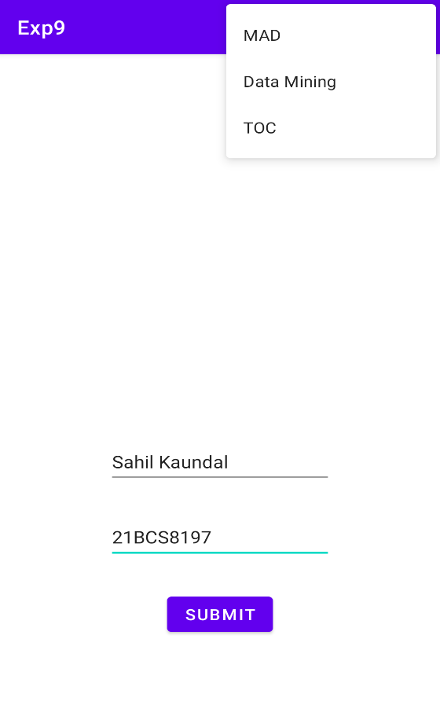 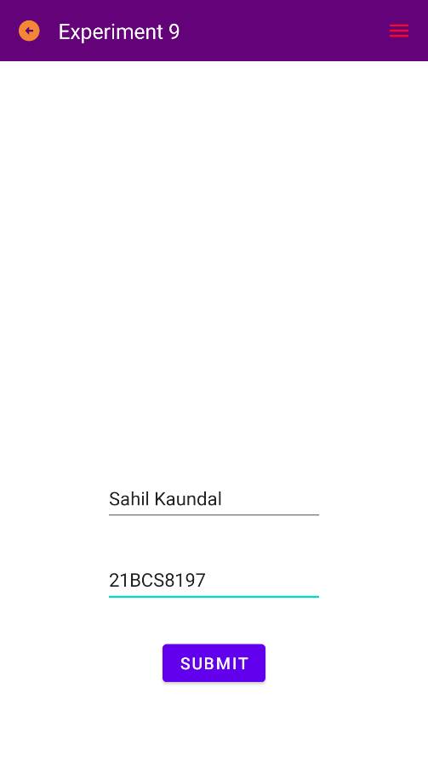

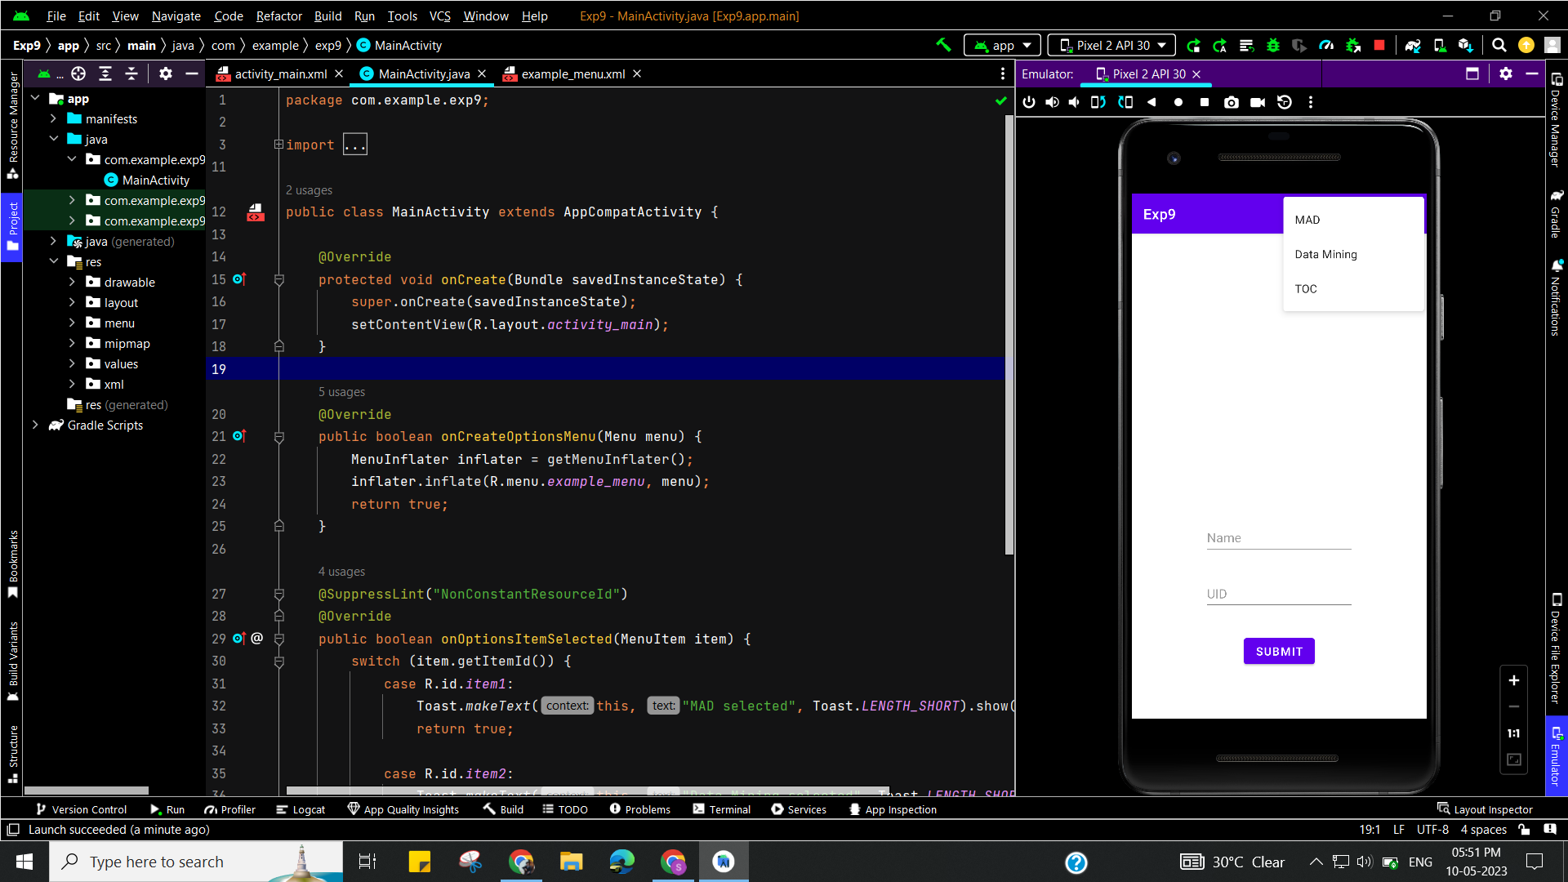

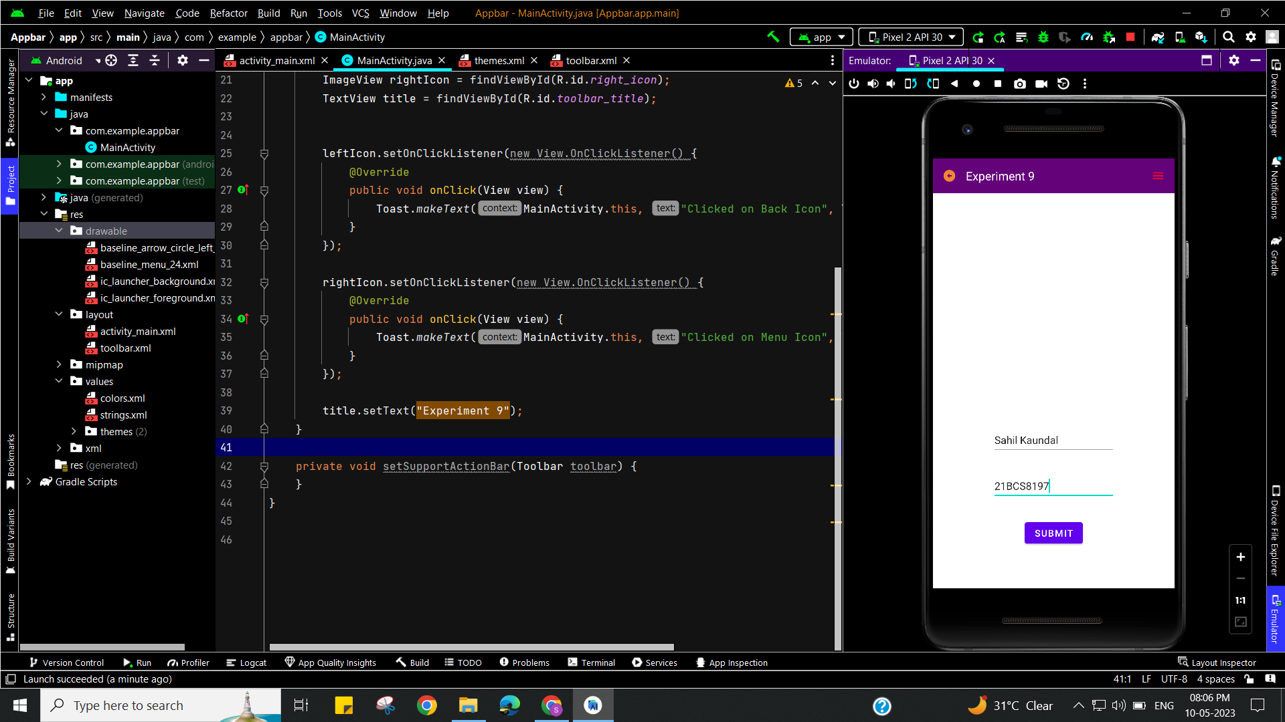

**Learning outcomes (What I have learnt):**

* To design an android application which uses menus and action bar in android studio.
* Learnt about running application on android studio.